**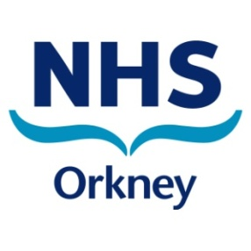**

**NHS Orkney Director of Finance**

**Candidate Information Pack**

**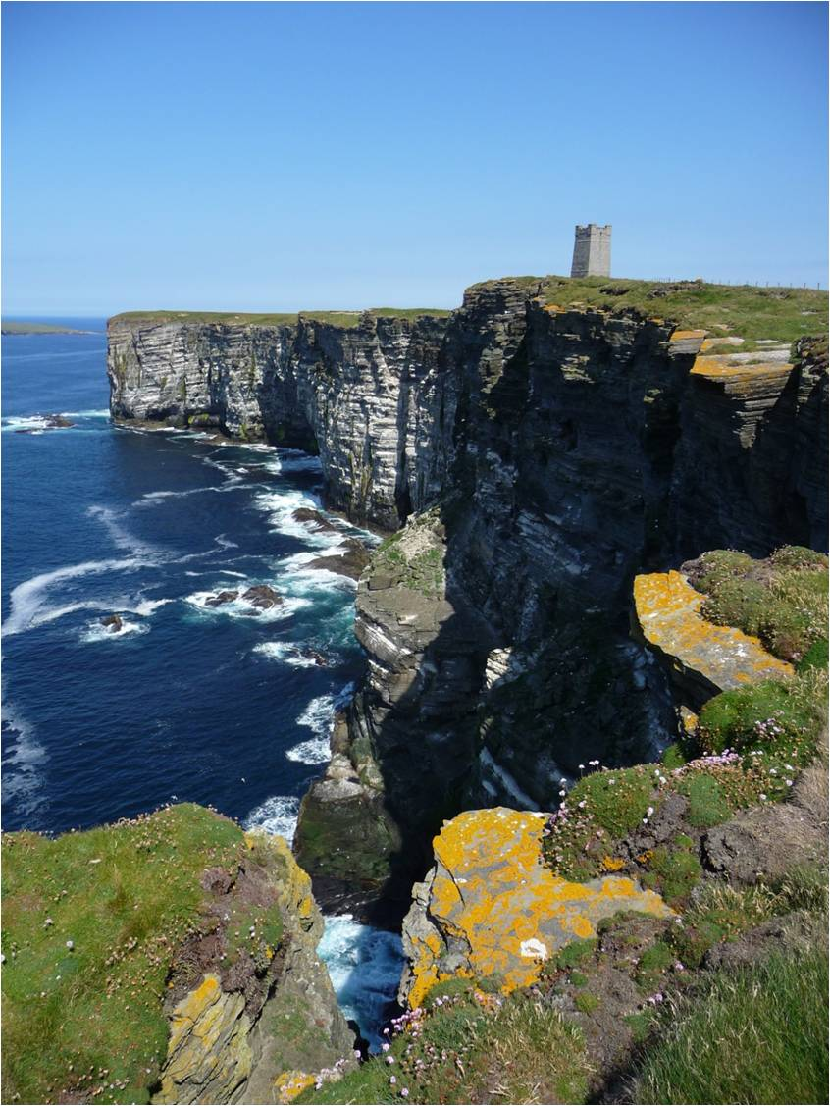**

**Application Contents**

|  |  |
| --- | --- |
| Contents | Page |
| Welcome | 3 |
| Advert | 4 |
| Job Description | 6 |
| Person Specification | 11 |
| Information for Applicants | 13 |
| Role Specific Additional Information | 15 |
| Introduction on Orkney | 16 |
| Board Members | 18 |
| Appointment Statement Terms and Conditions | 19 |
| Selection Process and Recruitment Timetable | 22 |

**Welcome**

Dear Candidate

Thank you for your interest in the post of Director of Finance of NHS Orkney. NHS Orkney is an organisation of talented people who care, work hard and live up to our values.

The role of Director of Finance is an excellent opportunity for an exceptional person who can evidence outstanding leadership qualities. We want a Director of Finance who can look after our finances in a style and manner that engages the Board, managers and our staff and through this contributes to improving the health of the people of Orkney and the care and services that our patient’s experience.

NHS Orkney is currently implementing a significant transformation agenda which includes a new build hospital and healthcare facilities, integration of health and social care alongside an improvement agenda that underpins our three quality ambitions: person centred, safe and effective care.

There is no doubt that this role offers a rewarding career opportunity where the successful candidate will join and add to the strength of our Executive Management Team and work closely and supportively in partnership with clinical and non clinical staff and their representatives to implement our Financial Strategy.

If you are inspired by the challenges this opportunity presents and believe you have the relevant skills, experience and qualities we are seeking, we look forward to receiving your application which will be given careful consideration.

Yours sincerely

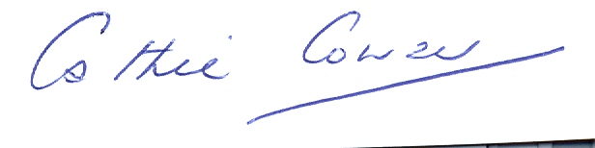

Cathie Cowan

Chief Executive

NHS Orkney



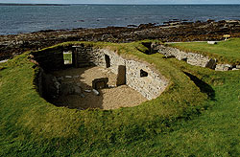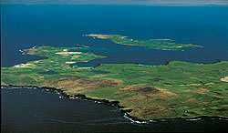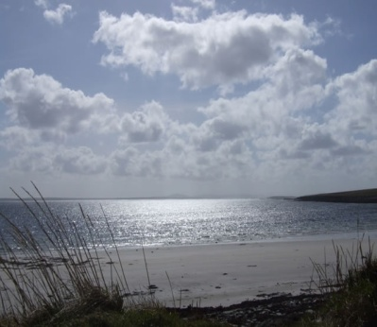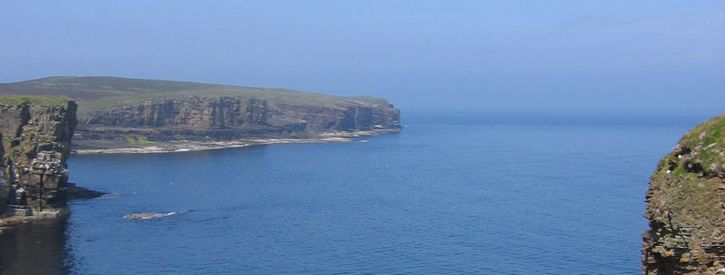

**Are you interested in practising in an area of outstanding natural beauty?**

**Director of Finance**

#### Executive Level C: £57,841- £78,830 plus Distant Islands Allowance of £1,137.

**Full Time – Permanent position**

**Relocation package available up to £8,000, subject to eligibility**

NHS Orkney is looking to appoint an inspiring individual, a strategic thinker to join our Executive and Corporate Management Teams, to contribute to and participate in the strategic direction, performance management and governance of NHS Orkney.As the Director of Finance you will provide overall leadership to and management of the Finance, Estates and Facilities and e-Health Services of NHS Orkney, ensuring the development and implementation of the financial strategy underpins the Clinical Strategy. You will contribute to the direction, planning and implementation of organisational change throughout NHS Orkney to strengthen management performance and underpin service provision

Rise to the challenge and enjoy the opportunity – Orkney is a wonderful place to live and work and voted the happiest place to live in the UK. Orkney also offers low pollution, low crime, excellent schools, good leisure facilities, unique wildlife and amazing scenery. Orkney is truly a place for children, a great place for a family and the community spirit is amazing.

You might think Orkney is remote, and whilst there are remote islands, Kirkwall has several flights a day (just under 1 hour) connecting to the mainland, and with high speed broadband available on the islands, friends and family are just a click away.

Homes are very affordable, what might you get for £200,000 in London, Edinburgh, Glasgow or Leeds? For that sort of money, you get 4 bedroom detached homes in the most sought after locations in Orkney and the best bit is there being very little traffic anywhere.

But don’t take our word for it - come and see for yourself! Please feel free to visit the island and the Balfour Hospital where you will find a very warm welcome.

You will be CCAB qualified Accountant with significant post qualifying experience and in depth professional knowledge. You will have extensive leadership and management skills developed at senior level in a large and complex organisation and a track record of delivering and meeting performance targets. Experience in managing significant financial resource within the NHS would be advantageous.

To find out more about living and working in Orkney visit [www.orkney.org](http://www.orkney.org/). Additional information on the islands and NHS Orkney can be viewed on [www.visitorkney.com](http://www.visitorkney.com/) and [www.ohb.scot.nhs.uk](http://www.ohb.scot.nhs.uk/).

For a confidential discussion on the role, please contact Donogh O’Brien at our recruitment partners, Aspen People, on 0141 212 7555.

To apply, please send your completed Application Form and Equal Opportunities Form to Katy Gall at [kgall@aspenpeople.co.uk](mailto:kgall@aspenpeople.co.uk) quoting reference G913.

**Closing date for applications: Wednesday 13th May 2015**

*This post is subject to a Disclosure Scotland Check.*



**JOB DESCRIPTION**

|  |  |  |
| --- | --- | --- |
| **1.** | **SERVICE DIRECTORATE/DEPARTMENT** | Finance Directorate |
| **2.** | **JOB TITLE** | Director of Finance |
| **3.** | **GRADE** | Executive C |
| **4.** | **REPORTING TO** | Chief Executive Officer |

|  |
| --- |
| **5. JOB PURPOSE** |
| As a corporate member of the NHS Orkney Board and Executive Management Team to contribute to and participate in the strategic direction, performance management and governance of NHS Orkney.  To provide overall leadership to and management of the Finance, Estates and Facilities and e-Health Services of NHS Orkney, ensuring the development and implementation of the financial strategy underpins the Clinical Strategy.  To contribute to the direction, planning and implementation of organisational change throughout NHS Orkney to strengthen management performance and underpin service provision.  As Director of Finance, support the Board with financial and other business advice, to permit discharge of responsibilities for public accountability; the operation of effective systems and the highest professional standards of financial control and corporate governance; and to ensure that financial targets for the year are met in a manner that maintains financial stability. This includes ensuring that systems of internal control are in place to provide external assurances on the integrity and completeness of financial activities. |
|  |
| **6. DIMENSIONS** |
| * + Annual NHS Orkney Budgets; Revenue £52m   Capital (variable) Anticipated range £1m to £7m pa |

|  |
| --- |
| **7. ORGANISATIONAL POSITION** |
|  |
|  |
| **8. KEY RESULT AREAS** |
| As the Director of Finance of NHS Orkney advise the Board and ensure the financial aspects of strategic and operational planning, resource allocation, performance management and governance of the Board’s services reflect national priorities, Board policies and statute to meet the healthcare needs, and improve the health, of the people and communities of Orkney.  To advise and support the Chief Executive to lead the Board of NHS Orkney and support the Board as whole to fulfil its role.  To direct and lead the Finance, Estates, Facilities and e-Health Team, ensuring understanding and commitment to the strategic objectives of NHS Orkney, to achieve clinical/service excellence and health improvement.  To provide high level leadership and direction to the continuing development and redesign of financial management, ensuring that budgetary control and accountability is effectively delegated and that managers have the appropriate skills and support in order to discharge their duties of accountability.  To contribute with appropriate financial expertise to project management and organisational change to enable service redesign to be effective.  To lead and represent the financial interests of NHS Orkney in the regional and national context. Also to contribute to relevant regional and national developments to influence policy and strategy developments and ensure NHS Orkney issues are reflected.  Contribute to collaborative working with other agencies to promote and develop the health service and other issues impacting on the determinants of health, to enhance the health and well being of the people and communities of Orkney.  Ensure direct reports are supported, developed and managed to enable them to maximise their contribution to the work of NHS Orkney and their potential, including leadership and management capability.  Exhibit and exemplify leadership behaviours with all staff, and other stakeholders, ensure effective partnership working with staff and staff organisations, and achievement of the Staff Governance Standard.  Ensure NHS Orkney manages within its budget and that all resources available are utilised efficiently and effectively, in accordance with strategic aims and the Local Delivery Plan. Also ensure that the systems and processes of performance management function effectively  Support the Chief Executive in the role of Accountable Officer for NHS Orkney to provide for the financial probity of the organisation; with accountability to the NHS Board, the Chief Executive SGHSCD and the Scottish Parliament for these functions. |

|  |
| --- |
|  |
| 1. **ASSIGNMENT AND REVIEW OF WORK**   This post has a high level of autonomy within NHS Orkney, working in a self-directed fashion within the parameters of Government priorities and policies for health, and other national regulatory frameworks such as legal and professional frameworks for accountancy practice and corporate governance. The post also operates within the NHS Board’s own strategic framework, to which the postholder contributes as an executive member of the Board. The responsibility for providing specialist professional advice to the Board on financial management rests with the postholder.  Review of performance in the post is undertaken through the agreement of performance objectives and individual performance appraisal by the Chief Executive, reviewed by the Remuneration Committee. The Chairs of the Audit Committee and the Finance and Performance Committee may also influence objectives and performance appraisal. Formal appraisal is undertaken on an annual cycle, but the Chief Executive and/or the Board/ Committees will undertake more frequent, ongoing, informal reviews of current developments and progress on major issues on an ongoing basis, giving authority where necessary for the postholder to proceed with matters out with the scope of his/her delegated authority. |
|  |
| 1. **COMMUNICATION AND WORKING RELATIONSHIPS**   The postholder is expected to communicate with Board Directors and with a wide range of senior clinical and non-clinical staff across NHS Orkney and with senior officials of external organisations. Excellent communication skills are required since a major purpose of communication is to persuade others, and negotiate the implementation of change.  The postholder is expected to have strong presentation skills and to be able to express a view convincingly and coherently, verbally and in writing.  Excluding the potholder’s immediate manager (the Chief Executive) and his/her subordinates within NHS Orkney, the following are key working relationships, with examples of the purposes of these contacts.   * With Non-Executive Directors (including the Employee Director) of the NHS Board; the Chair and members of the Audit Committee and the Chair and members of the Finance & Performance Committee – to ensure the provision of information and support to enable them to effectively fulfil their roles are non-executives, particularly in relation to the financial probity and corporate governance of NHS Orkney. * With colleague Executive Directors and other senior managers, clinical staff and primary care colleagues within NHS Orkney – working with them in the planning, delivery, evaluation and development of services. * With Executive Directors of other NHS systems – e.g. to represent NHS Orkney in discussions relating to financial matters arising from regional service planning. * With the Director of Finance and other members of the Management Team in the Scottish Government Health and Social Care Department – e.g. to agree NHS Orkney’s financial performance objectives and to participate in the Accountability Review process. On an ad hoc basis to discuss and resolve difficult or controversial issues relating to national policy or the financial performance of NHS Orkney. To respond to Parliamentary Questions. * With representatives of Local Government, voluntary and independent sector agencies, and private sector organisations – e.g. representing the NHS Board to discuss and agree resourcing or financial management arrangements relating to joint service provision. * With MPs/MSPs/Local Health Council Chairs/Public Pressure Groups/Patient Representatives/etc – e.g. to impart information about/respond to questions or concerns about financial issues relating to NHS Orkney. * With the media – e.g. to respond to media questions about matters relating to the financial management of NHS Orkney. * With national and local representatives of Trade Unions and Professional Organisations – e.g. for communication and/or consultation on major issues relating to the financial management of NHS Orkney. |
|  |
| 1. **MOST CHALLENGING PART OF THE JOB**   To ensure in a rapidly changing environment, that the fundamental aim of making the best use of limited resources available to the Board for health gain within the population is achieved, and that the work of NHS Orkney is delivered within its set financial parameters.  To manage a diverse portfolio of high profile and corporate activities, whilst seeking to formulate and gain commitment to a financial strategy that achieves a balance of meeting internally competing demands, supports the long term strategy of the Service, and seeks to meet the expectations of the wider NHS Scotland and Scottish Government. All of this to be achieved within a framework that maintains the highest standards of probity and control. |
|  |
| 1. **QUALIFICATIONS AND/OR EXPERIENCE SPECIFIED FOR THE POST**   The post requires an individual who demonstrates competencies in the critical leadership behaviours identified as crucial to achieving success within NHS Scotland.   * Working in partnership * Learning and Development * Caring for Staff * Improving performance through team working * Communicating effectively * Improving quality * Achieving results   The postholder will require a high level of interpersonal, strategic and technical skills combined with a supportive and visible leadership style. He/she must have the stature to earn the confidence and respect necessary to effectively lead a major corporate function and deliver the agenda of major change. It will be essential to have the skills to develop a culture that encourages initiative, individual and team responsibility with open communication that motivates staff.  The postholder will be a qualified accountant and be educated to degree level preferably with postgraduate or equivalent qualifications. He/she will have a minimum of 7 years post qualification experience at Senior Management level. |

**Person Specification**

Candidates must have proven experience in the following essential criteria. The ideal candidate will also be able to demonstrate experience of the desirable criteria. Responses to your application will be further developed and discussed with those candidates invited for interview.

|  |  |  |
| --- | --- | --- |
| **FACTOR** | **ESSENTIAL** | **DESIRABLE** |
| QUALIFICATIONS  TRAINING  RESEARCH  PUBLICATIONS | CCAB Qualified  Qualified to Degree level with significant post qualifying experience and in depth professional knowledge acquired through experience  Demonstrates continuous professional development | Post Graduate or equivalent level qualification |
| EXPERIENCE | Extensive leadership and management skills developed at senior level in a large and complex organisation  A track record of delivering and meeting performance targets  A track record of demonstrable leadership including experience of influencing and motivating others to form positive relationships at all levels to achieve continuous improvement and transformational change.  Experience of delivering key workforce projects in partnership with trade union colleagues  Experience of developing effective relationships and productive links with external stakeholders and working successfully in a political environment  Experience of managing significant financial resources with strong appreciation of relevant regulatory frameworks. | Experience in managing significant financial resource within the NHS with strong appreciation of relevant regulatory frameworks/NHS operating framework  Senior board level experience in the NHS or other large dynamic organisation |
| KNOWLEDGE AND SKILLS | Strong persuasive, influencing and interpersonal skills  Strong skills in strategic planning and strategic management of financial resources  Strong decision making skills with the ability to make decisions and recommendations based on the analysis of options  A track record of building and maintaining robust and co-operative relationships with colleagues throughout the organisation and external stakeholders  Is skilled at explaining complex information, concisely, clearly and accurately in order to inform and persuade others  To be a supportive and visible leader and be able to motivate and support the Finance, Estates and E-health teams  Ability to negotiate diplomatically and manage conflict  To be able to assess complex plans and strategy and turn these into delivery plans  Demonstrate commitment to and achievement of, equality and diversity issues in public sector services |  |

# 

# Information for Applicants

**NHS Scotland**

The NHS is one of our nation’s biggest and most important public services. Each day thousands of Scots depend on it for treatment and care. Each day it saves hundreds of lives.

The nation’s largest employer, more than 150,000 dedicated and skilled staff work for NHS Scotland. Since devolution, the Scottish Government has been striving to make Scotland healthier for all of us.

The work undertaken by the 14 territorial NHS Boards across the country provides the strategic framework to ensure that the management of our healthcare is more efficient, more accountable and more effective. These Boards bring together key partners to deliver healthcare. One of the main functions of these different bodies is to put government policies into practice in the best way possible.

An NHS Board is a board of governance, which has responsibility for issues such as health improvement, strategic planning and resource allocation.

**NHS Orkney**

NHS Orkney is one of 14 Scottish territorial health boards. Headquartered in Kirkwall, the Board is responsible for improving the health of the population, improving patient experience whilst also delivering sustainable, affordable and comprehensive health care services for the Orkney Island communities. NHS Orkney employs 594 substantive employees with a wide range of general and specialist skills. NHS Orkney being the smallest territorial Board,

NHS Orkney serves a population of approximately 20,500 dispersed across three distinct regions – the North Isles, the South Isles and the Mainland, which collectively consist of 17 inhabited Islands, the largest of which is the Mainland of Orkney

NHS Orkney is working with its remote island communities to develop a sustainable Primary Care model that reflects the health needs of each island. Our Isles Network of Care is a model which brings together single handed practitioners in a network arrangement. The network is made up of GPs, nurse practitioners and community nurses.

NHS Orkney’s vision is to:

***“Offer everyone in Orkney access to a NHS that helps them to keep well and provides them with high quality care when it is needed whilst employing a skilled and committed local workforce who are proud to work for NHS Orkney.”***

The Board Comprises of 15 Members. There are three types of Members; Appointed Members, a Councillor Member and Elected Members.

The Appointed board members

* The Board Chairperson and Vice
* 6 Non- Executive Members
* 2 Stakeholder Members

- Employee Director

- Chair of Clinical Forum

* 4 Executive members

- Chief Executive

- Medical Director

- Director of Public Health

- Director of Nursing, Midwifery and Allied Health Professionals

In attendance:

- Director of Finance

- Head of HR Services

The Non-Executive members are lay-people who are invited to sit on the Board. These people generally have other jobs but they receive some remuneration for activities involving their Health Board duties.

The 9 Non-Executive Members who are elected under the terms of The Health Boards (Membership and Elections) Scotland Act 2009. Further, one Non- Executive member is a councillor member - a Member of Orkney Islands Council, nominated by the Council, and appointed by Scottish Ministers;

And the Executive Members are all senior managers and therefore employees of NHS Orkney.

**Role Specific Additional Information**

*To assist you with your application for the post of Director of Finance, NHS Orkney, please click the following links and hyperlinks to view documents*

* **NHS Orkney Financial Plan**



* **NHS Orkney Strategic 20:20 Vision**



* **NHS Orkney Corporate Plan**

****

* **Orkney Integration Scheme** (please ignore reference to annex)



* **NHS Orkney New Hospital and Healthcare Facilities**



* **Clinical Strategy – Our Orkney our Health**

[**Clinical Strategy**](http://www.ohb.scot.nhs.uk/images/pdf/Board%20Paper%20Our%20Orkney%20Our%20Health%20June%202009.pdf)

**Useful websites**

* NHS Orkney - <http://www.ohb.scot.nhs.uk/> - see ‘links’ tab for more website links
* Orkney Island Council - <http://www.orkney.gov.uk/>
* Scotlands Health On The Web (SHOW) - <http://www.show.scot.nhs.uk/>
* NHS Orkney Twitter - [www.Twitter.com/nhsorkney](http://www.twitter.com/nhsorkney)
* NHS Orkney Facebook – <https://www.facebook.com/nhsorkney>

# Introduction to Orkney

Lying off the northern coast of Scotland, between John O’Groats and the Shetland Isles, Orkney is an archipelago of over 70 beautiful islands, 17 of which are inhabited.

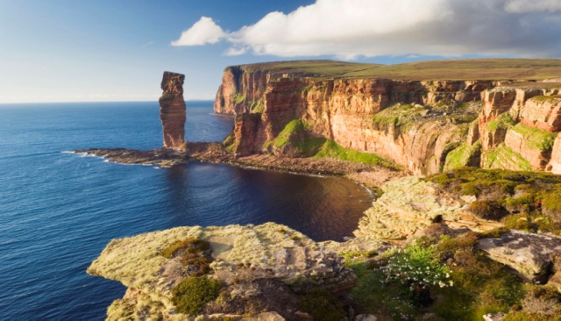

The total population is approximately 22,000 with approximately 80 percent living on the Mainland of Orkney. Kirkwall, the capital with its spectacular red sandstone 12th century cathedral, with a population of 7,500, it is the administrative centre of Orkney with a good mix of shops, supermarkets and businesses.

The smaller town of Stromness has a population of about 2,500 situated in the West Mainland.

To the East of the Mainland, with a population of around 1,500, are the islands of South Ronaldsay and Burray. The remote and north isles vary in population from 1 person to circa 600. Orkney is a wonderful place to live and work and voted the happiest place to live in the UK. Orkney also offers; low pollution, low crime, excellent schools, good leisure facilities, unique wildlife and amazing scenery.

Orkneys economy is mainly occupied by the farming industry. Commonly within Orkney Most farmers breed and rear beef cattle of the highest standard, although dairy cows and sheep are also kept. Agriculture is the main industry of the islands and generates some £30 million per year, followed closely by tourism and oil. And fishermen compete with seals and sea birds to enjoy something of the rich bounty provided by the surrounding seas. Orkney is at the forefront of the renewable energy drive in the UK. Wind turbines are dotted around the islands and wave energy research is on-going.

In economical terms Orkney hold an impeccable rate of those in employment/seeking, with the percentage of 84.7, the islands statistics are above the average for Scotland and Great Britain. Thus, unemployment levels are again on average lower than Scotland and the UK, in relation to long-term unemployment.

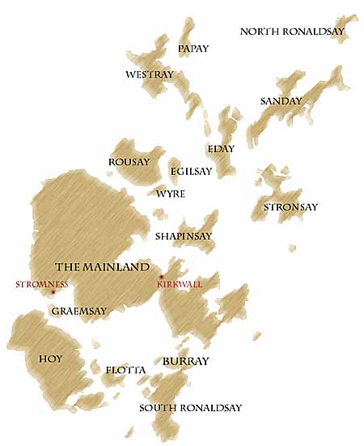

Kirkwall is truly a place for children, a great place for a family. The community spirit is amazing. There is so much for children and adults - theatre, drama, dance and ballet classes. Schools in Kirkwall are very good (no private fees). And for adults visiting relatives and friends there is so much to see and do, playing a round of golf, fishing, kayaking, walking, cycling, diving, wind surfing are but a few. The Pickaquoy centre provides a lovely modern well equipped gymnasium and entertainment centre.

Imagine all of these within walking distance of your home and workplace.

Houses and farms are dotted all over the gently rolling landscape and the sea is never more than a few miles away.

The Gulf Stream passes close by giving Orkney a surprisingly temperate climate. Frost and snow do not occur as often as may be expected, but it is very windy with the landscape dominated by the panoramic skies. There are often dramatic changes in the weather and it is said that you can experience all four seasons in the course of a few hours. The days are short and dark in winter, but in the summer it is possible to read or play a round of golf late into the evening in the long days of June and July

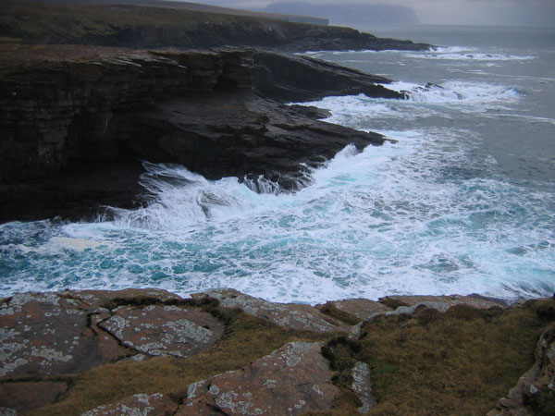

To the archaeologist, Orkney is rich in ancient monuments. Tourists come from all over the world to admire the 12th Century St Magnus Cathedral in Kirkwall and other spectacular heritage.

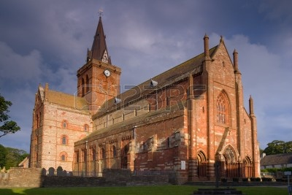

The Neolithic village of Skara Brae is one of the most important sites in Europe. It has received World Heritage Status along with the burial mound at Maeshowe and the majestic standing stones of the Ring of Brodgar and the Standing Stones at Stenness.

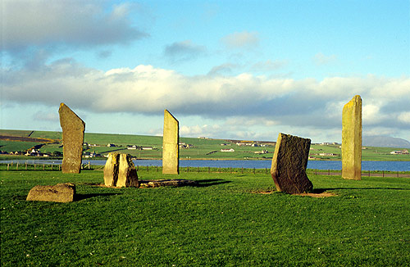

Older than Stonehenge, the Great Wall of China and the Pyramids, Orkney's Neolithic sites give a vivid insight into the lives and beliefs of our ancient settlers.

# Board Members

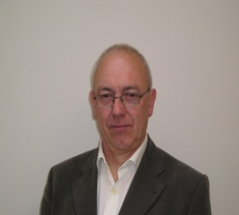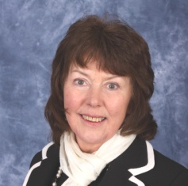

**John Ross Scott Liz Middleton**

Chairman Vice Chair

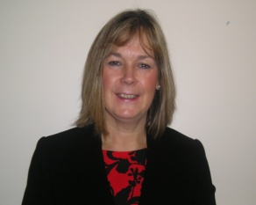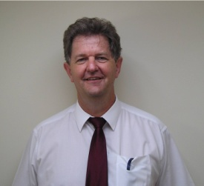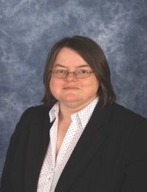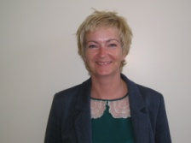

Post vacant

|  |  |  |  |  |  |  |
| --- | --- | --- | --- | --- | --- | --- |
| **Julie Nicol**  Head of HR Services  (in attendance) | G:\Human Resources\Recruitment\badges\Photo Library\Cathie Cowan Chief Executive.jpg      **Cathie Cowan**  Chief Executive | Director of Finance | **Louise Wilson**  Director of Public Health | **Marthinus Roos**  Medical Director | **Elaine Peace**  Director of Nursing, Midwifery and Allied Health Professions |  |
| G:\Human Resources\Recruitment\badges\Photo Library\Jeremy Richardson - Non Exec Board Member.jpgG:\Human Resources\Recruitment\badges\Photo Library\Naomi Bremner Non Exec Board Member.JPG | G:\Human Resources\Recruitment\badges\Photo Library\Ronnie Johnston - Executive Board Member.JPG | **G:\Human Resources\Recruitment\badges\Photo Library\Gillian Skuse - Non Exec Board Member.jpg** |  | **C:\Documents and Settings\rachael.suttie\My Documents\My Pictures\NHS_StephenHagan_02.jpg** | Victoria Anderson School Nurse.JPG | G:\Human Resources\Recruitment\badges\Photo Library\Andy Trevett Acute GP.JPG |
| **Jeremy Richardson**  Non Executive Member  **Naomi Bremner**  Non Executive Member | **Rognvald Johnson**  Non Executive Member | **Gillian Skuse**  Non Executive Member |  | **Councillor- Stephen Hagan**  Non Executive Member | **Vicky Anderson**  Employee Director | **Andy Trevett**  Chair of Area Clinical Forum |

# Appointment Statement Terms and Conditions

#### This is a full time appointment.

#### A package commensurate with the responsibilities of the post and the level of seniority of the successful candidate will be available to the appointed candidate.

#### Confirmation of appointment will be subject to satisfactory completion of Pre Employment Checks including; Satisfactory References, Occupational Health Check, Evidence of Professional Qualifications, Eligibility to legally work in the UK and a Disclosure Scotland check etc.

#### General

#### The terms and conditions for this post are set by direction of Scottish Ministers under the arrangements in place for Executive and Senior Managers Pay within NHS Scotland.

#### 2. Salary

#### The grade and salary range for this post is Executive and Senior Managers

#### Pay Level: Grade C. £57,841- £78,830 plus Distant Islands Allowance of £1,137.

#### Placing on the range will be determined by a range of factors, taking into account current salary. The starting salary will be part of the formal offer of employment. Progression through the pay range is on the basis of an annual assessment of performance in a year beginning 1st April and ending 31st March. A pay uplift determined by performance rating is applied in line with national circulars.

#### 3. Hours of Duty

#### The set hours of work are 37.5 per week; however, the number and pattern of hours will reflect the demands of the post. There is no contractual right to additional pay or time off in lieu for additional hours. This will not affect individual rights under the Working Time Directive.

#### 4. Pension Arrangements

#### New entrants to NHS Orkney who are aged sixteen but fewer than seventy five will be enrolled automatically into membership of the NHS Pension Scheme.

#### Our pension scheme is provided by Scottish Public Pensions Agency. This scheme is a qualifying pension scheme, which means it meets or exceeds the government’s new standards. All benefits including life insurance and family benefits are explained on the SPPA website http://www.sppa.gov.uk/

#### Once a year, (following 2 years qualifying service) a statement is available online (http://www.sppa.gov.uk/) showing how much service has built up in your pension.

#### You can increase the amount you put in if you want by buying additional pension. For full details please see the Factsheet “Additional Pension” available on the SPPA website http://www.sppa.gov.uk/

#### The amount contributed by the government in the form of tax relief would also increase.

#### Superannuation benefits accrued in the NHS Scheme elsewhere in the UK can be transferred to the Scottish scheme by arrangement with the Scottish Public Pensions Agency. The transferability of other public sector pension schemes entitlements may be possible and may be explored on appointment.

#### 5. Location

#### For employment purposes, your base will be the Board Headquarters, Garden House, New Scapa Road, Kirkwall KW15 1BQ

#### The post will inevitably require you to travel regularly throughout the Board’s area and within Scotland.

#### Less frequently you will be required to travel further out with Scotland. Home to work expenses will be met by the post holder but all other travel expenses incurred as a result of your employment will be reimbursed by the Board.

#### 6. Removal Expenses

#### Reasonable removal expenses in line with the Board’s policy will be payable, up to a maximum of £8,000. This will be discussed with you, as part of an offer of employment.

#### 7. Annual Leave

#### The annual leave entitlement is 27 days rising to 29 days after 5 years service and 33 days after 10 years service.

#### Public Holidays (8 days) are allocated in addition for all Board employees.

#### 8. Performance Appraisal and Personal Development

#### The annual performance cycle is from 1st April to 31st March. Performance is assessed against a performance plan, which contains individual service objectives relating to the Board’s corporate objectives and individual behavioural objectives based on the NHS Scotland Leadership Competency Framework. The performance plan is agreed with the Chief Executive.

#### Performance against the plan is assessed by the Chief Executive and performance is rated on a five point rating scale:-

#### 1. Unacceptable – misses most targets

#### 2. Incomplete – misses most targets without counterbalancing over-achievements

#### 3. Fully Acceptable – balances shortfalls with over-achievements

#### 4. Superior – meets all targets and exceeds most

#### 5. Outstanding – substantially exceeds all targets

#### 9. Other Terms and Conditions of Service

#### Terms and Conditions of Service which are not set down in the arrangements for Executive and Senior Managers Pay, are those contained within the Agenda for Change Terms and Conditions Handbook, and the Board’s Human Resources Policies.

# Recruitment and Selection Process and Timetable

**Process**

There are 3 stages to the selection process following shortlisting:

**Stage 1:** An assessment centre consisting of a numerical, verbal and personality test - this will be carried out online.

**Stage 2:** Meet and greet of the panel members and close colleagues.

**Stage 3:** 10 Minute presentation followed by formal competence based interview conducted by the appointment panel:

* Cathie Cowan – Chief Executive, NHS Orkney
* John Ross Scott – Non Executive Chair, NHS Orkney
* John Matheson – Director of Finance, Scottish Government
* Alan Gray – Director of Finance, NHS Grampian
* Julie Nicol – Head of HR Services, NHS Orkney
* Donogh O’Brien – Director, Apsen People
* Naomi Bremner – Non-Executive (Chair of Audit Committee)
* Rognvald Johnston – Non- Executive (Chair of Finance and Performance Committee)

Please see links below for Application Form, Declaration of Suitability and Guidance for completion:



* Please note that correspondence regarding your application will be sent by email. If this method is not suitable for you, please inform Katy Gall.
* If you would like to discuss any aspects of this post prior to submitting an application, please contact Donogh O’Brien at our recruitment partners, Aspen People, on 0141 212 7555.
* The closing date for applications is Wednesday 13th May 2015

|  |  |
| --- | --- |
| Proposed Timetable |  |
| Closing Date | 13th May 2015 |
| Shortlisting taking place | 18th May |
| Candidates notified of shortlisting outcome | 20th May |
| Candidates complete online assessment | By Monday 8th June |
| Meet and Greet | 15th June |
| Formal Interviews | 16th June |

**Special Requirements for Selection Events**

Where appropriate NHS Orkney is fully supportive in discussing making any reasonable adjustments to the recruitment process to ensure no candidate is disadvantaged as a result of a disability or any other health condition.